Amazon Product Co-Purchasing Network Analysis Report
1. Load the Dataset
The Amazon co-purchasing dataset was imported into Gephi as an undirected graph.
- Nodes: Products
- Edges: Co-purchasing relationships
- Total Nodes: 1000
- Total Edges: 2178
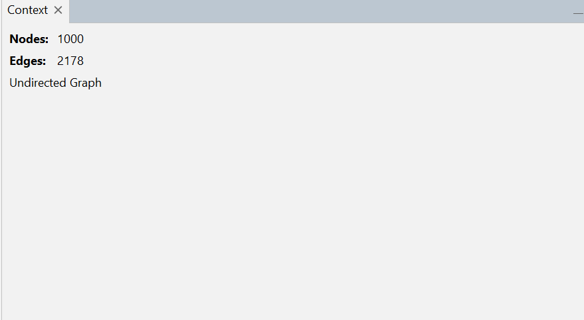

2. Graph Visualization
The ForceAtlas2 layout was applied to visualize the network clearly. Node sizes were adjusted using Degree ranking, and edge thickness was increased for better readability.
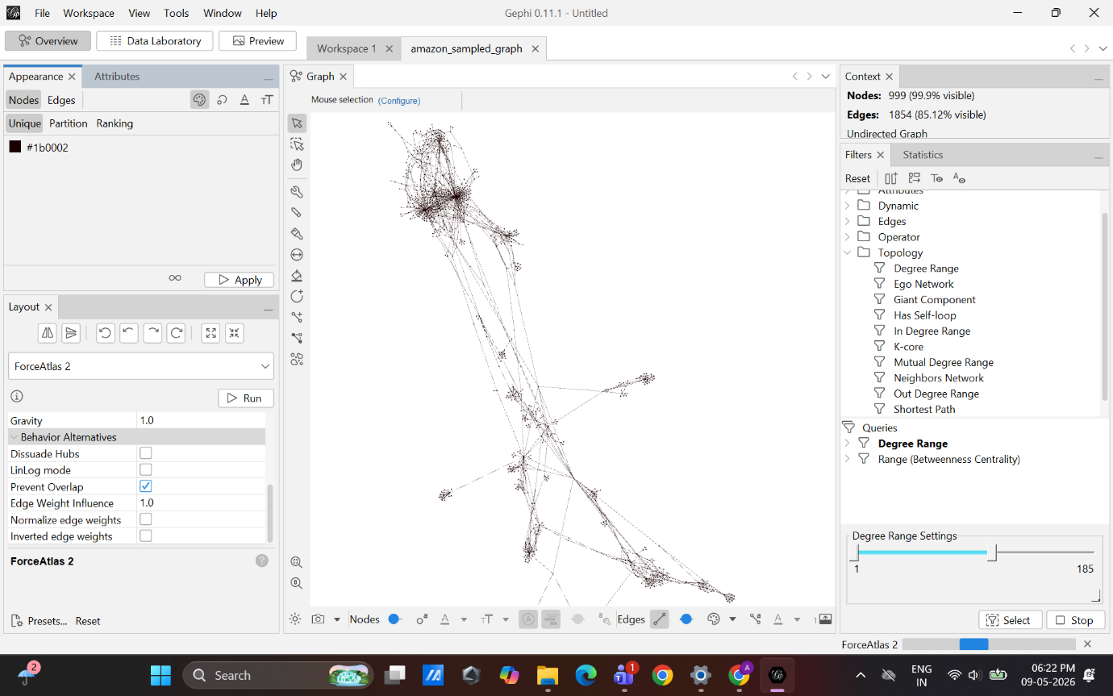

3. Degree Analysis
Degree Centrality was used to identify the most connected products.
Rank | Node ID | Degree
1 | 458358 | 324
2 | 38365 | 151
3 | 175102 | 92
4 | 37981 | 46
5 | 498702 | 46
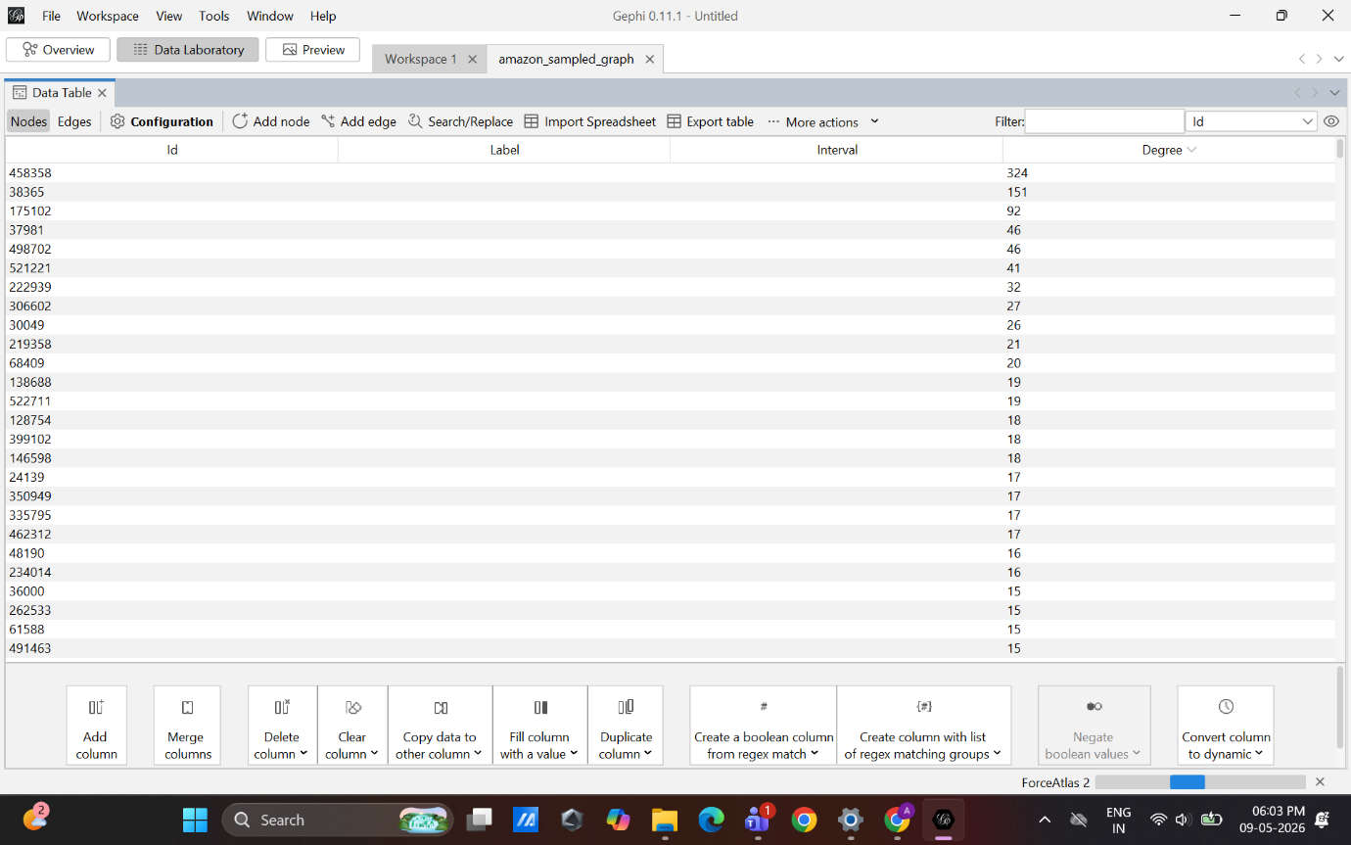

4. Centrality Measures
Top 5 Nodes by Betweenness Centrality
Rank | Node ID | Betweenness
1 | 458358 | 0.472667
2 | 58064 | 0.444364
3 | 24139 | 0.426438
4 | 522711 | 0.340592
5 | 38365 | 0.204298
Top 5 Nodes by PageRank
Rank | Node ID | PageRank
1 | 458358 | 0.06938
2 | 38365 | 0.03343
3 | 175102 | 0.01939
4 | 521221 | 0.00952
5 | 498702 | 0.00882
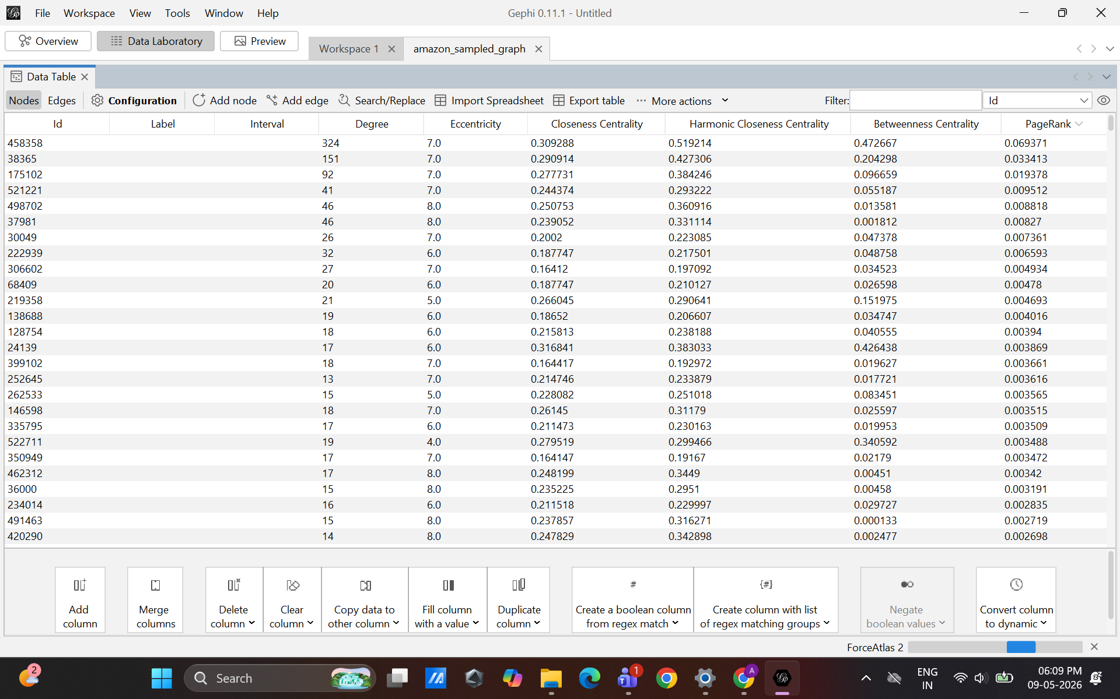

5. Community Detection
The Modularity algorithm was used to detect communities. Nodes were colored based on their modularity class to identify clusters of related products.
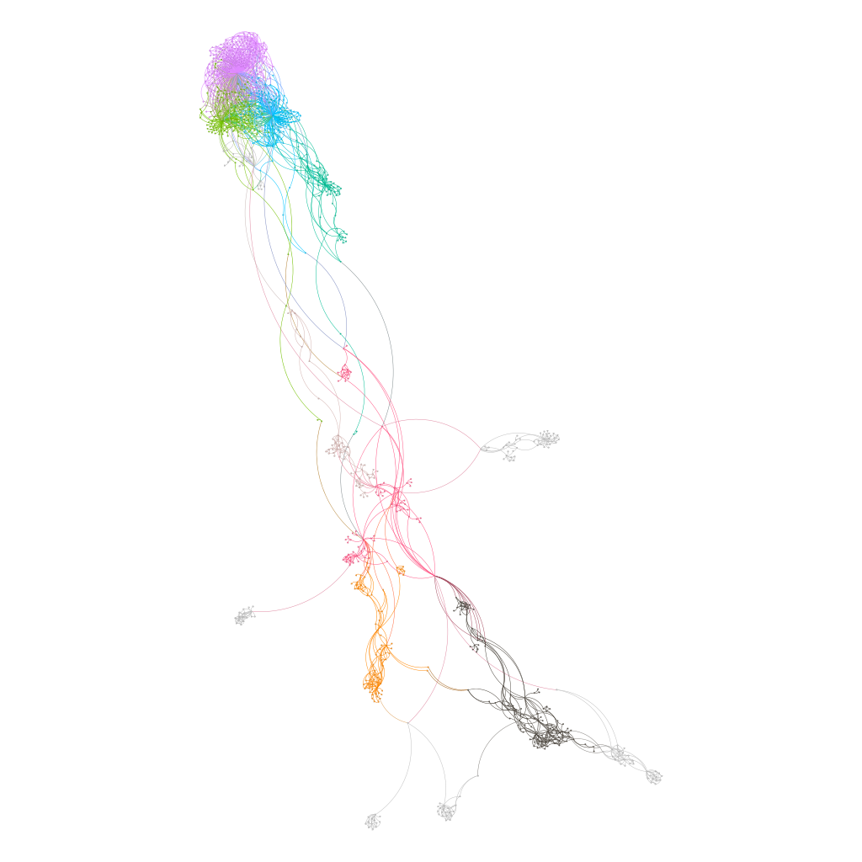

6. Filtering & Highlighting
- Highlighted nodes with highest Betweenness Centrality (Red color)

- Applied Degree Range filter to isolate high-degree nodes

- Made top 5 highest-degree nodes larger and colored them blue for emphasis



Conclusion
The network analysis identified important products, influential nodes, and product communities using Gephi.
The Amazon product co-purchasing network was successfully analyzed using Gephi. ForceAtlas2 visualization, Degree Centrality, Betweenness Centrality, PageRank, and Modularity algorithms helped identify important products and communities within the network.
The analysis showed that a small number of highly connected products dominated the network structure, while several bridge nodes connected different product communities. Filtering and highlighting techniques further improved the interpretation of influential nodes within the network.
This analysis demonstrated how network analysis techniques can be used to understand customer purchasing behavior in Amazon co-purchasing data. Degree Centrality helped identify highly connected products, while Betweenness Centrality and PageRank revealed influential products within the network.
Community detection using the Modularity algorithm showed clusters of related products and revealed the structural organization of the network. Filtering and highlighting further improved the interpretation of important nodes.
Overall, Gephi provided powerful visualization and analytical capabilities for exploring complex co-purchasing relationships and understanding product influence within the network. The analysis showed that a small number of highly connected products dominated the structure of the network, while bridge nodes with high betweenness centrality played an important role in connecting multiple product communities.

